**2021 Term 4**

**Year 7 Science**

**Earth and Space**



Name: ____________________________

Teacher:___________________________

Total Marks 35 Marks

**Section One: Multiple Choice (12 marks)**

1. The nearest star to Earth is:
2. Proxima Centauri.
3. Southern Cross.
4. the Sun.
5. Alpha Centauri.
6. How long does the moon take to orbit around the earth?
7. about one year
8. about one day
9. about 28 days
10. 52 weeks
11. As you move away from a planet, its gravitational force field:
12. gets stronger.
13. always stays the same.
14. weakens.
15. is zero.
16. 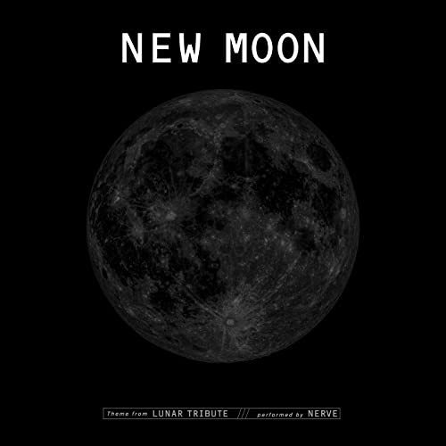The phase of the moon shown in this diagram is:
17. First quarter
18. New Moon
19. Full moon
20. Last quarter
21. A solar eclipse is when:
22. the moon travels around Earth in an orbit shaped like an oval.
23. the moon’s shadow appears on the Earth.
24. Earth blocks sunlight from reaching the Moon.
25. you only see part of the Moon because of its angle to the Sun.
26. Which of the following has a gravitational force field around it?
27. the Sun
28. the Earth
29. the person sitting next to you
30. All of the above
31. The 23.5° tilt of the earth is responsible for giving us:  
    * 1. The atmosphere
      2. headaches
      3. The four seasons
      4. Gravity
32. If a brick has a mass of 1 kg on Earth, it will have:
33. A mass of 1 kg on the Moon
34. A weight of 19.6 N on the Earth
35. A mass of only 0.3 kg on the Moon
36. A weight of 9.8 N on the Moon
37. State what phase the moon must be in for a solar eclipse to occur.
38. Crescent
39. New
40. First Quarter
41. Full
42. State why the seasons occur at opposite times of the year in the northern and southern hemispheres.
43. Because the North and South pole point towards the Sun at the same time.
44. Because the Earth is at different distances from the Sun at different times of the year.
45. Because the Earth is not a perfect sphere.
46. Because the Earth’s axis of rotation is tilted.
47. The Earth’s gravity is a force that attracts:
    1. objects to the Moon’s surface
    2. objects towards the centre of the earth
    3. objects to the North and South pole
    4. objects towards the surface of the Earth.
48. Night and Day on Earth are caused by:
    1. the Earth spinning around, once, on its axis
    2. the Moon completing a single orbit around the Earth
    3. the tilt of the Earth on its axis as it orbits the Sun
    4. the Earth completing a single orbit around the Sun

**Section 2: Short Answer (23 marks)**

1. How many days are there in a leap year? ______366 (1)____ (1 mark)

Explain why the leap year occurs. (2 marks)

1. Because the earth revolves around the Earth in 365.25 days. (1)
2. Every 4 years the extra quarter makes up a full extra day. (1)
3. When discussing the universe, a year 7 student claimed that he weighed the same on both Earth and the Moon.

**State** whether he was correct, (1 mark) and **justify** your answer. (3 marks)

1. Incorrect - **1**
2. The mass of the students stays the same - **1**
3. but his weight on the moon and earth are different - **1**
4. This is due to the different force of gravity on the Earth and Moon - **1**
5. **Explain** the terms *rotate* and *revolve* using the Earth as an example. (4 marks)
6. The Earth rotates on its axis (1)
7. This means it spins around an imaginary line through the centre of the Earth (1)
8. The Earth revolves around the Sun (1)
9. This means that the earth follows an orbit/Path around the Sun (1)
10. In the diagram below are two regions labelled A and B.
11. 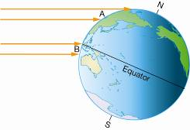
12. **Identify** which region (A or B) would have the hottest climate. (1 mark)

**____________________________**

**B** would experience the hottest climate

1. **Justify** your answer in part a). (2 marks)

**B** Sunlight strikes the Earth’s surface in Region B more directly and on less of an angle than in Region A. (1)

This concentrates the light and heat across a smaller area. (1) This makes Region B hotter than Region A.

1. **List 2** factors that affect the number of stars able to be seen in the night sky (2 marks)

a) Phase/Brightness of the moon

b) Cloud cover/ ambient light/air pollution)

1. Explain how different moon phases are created.  (3 marks)
2. Moon phases are created by the Moon orbiting around the Earth (1) as the Earth orbits around the Sun.
3. One half of the Moon is always illuminated by the Sun. (1)
4. As the Moon moves around the Earth, we see different amounts of light and shade, depending on the Moon's position. (1)
5. This creates different phases, which are the illuminated part of the Moon that we can see
6. Write the correct name of the following moon phases next to each diagram. The names have been supplied for you. (4 marks)

Waxing crescent Last quarter Waning Gibbous Full Moon

First Quarter Waxing Gibbous New Moon Waning Crescent

|  |  |  |  |
| --- | --- | --- | --- |
| **Diagram** | **Name of Phase** | **Diagram** | **Name of Phase** |
|  | New Moon |  | Full Moon |
|  | Waxing Crescent |  | Waning Gibbous |
|  | First Quarter |  | Last Quarter |
|  | Waxing Gibbous |  | Waning Crescent |

**END OF QUIZ**